[comments](http://maxembedded.com/2011/06/the-adc-of-the-avr/" \l "respond)

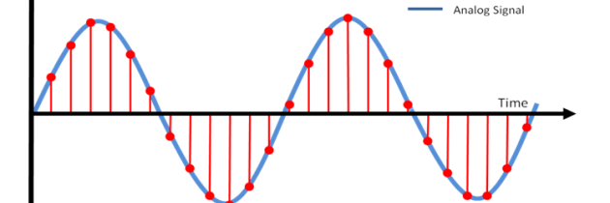

**The ADC of the AVR**

**Analog to Digital Conversion**

[](http://maxembedded.files.wordpress.com/2011/06/avr_series.png?resize=140%2C105)Most real world data is analog. Whether it be temperature, pressure, voltage, etc, their variation is always analog in nature. For example, the temperature inside a boiler is around 800°C. During its light-up, the temperature never approaches directly to 800°C. If the ambient temperature is 400°C, it will start increasing gradually to 450°C, 500°C and thus reaches 800°C over a period of time. This is an analog data.

[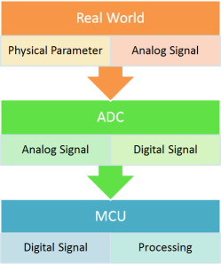](http://maxembedded.files.wordpress.com/2011/06/signal-acquisition-process.png?resize=249%2C298)

Signal Acquisition Process

Now, we must process the data that we have received. But analog signal processing is quite inefficient in terms of accuracy, speed and desired output. Hence, we convert them to digital form using an Analog to Digital Converter (ADC).

**Signal Acquisition Process**

In general, the signal (or data) acquisition process has 3 steps.

* In the **Real World**, a [sensor](http://maxembedded.wordpress.com/2011/06/18/sensor-fundamentals/) senses any physical parameter and converts into an equivalent analog electrical signal.
* For efficient and ease of signal processing, this analog signal is converted into a digital signal using an **Analog to Digital Converter (ADC)**.
* This digital signal is then fed to the **Microcontroller (MCU)** and is processed accordingly.

[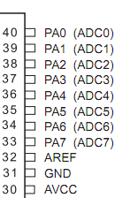](http://maxembedded.files.wordpress.com/2011/06/adc-pins-atmega16-32.png?resize=147%2C224)

ADC Pins – ATMEGA16/32

**Interfacing Sensors**

In general, sensors provide with analog output, but a MCU is a digital one. Hence we need to use ADC. For simple circuits, comparator op-amps can be used. But even this won’t be required if we use a MCU. We can straightaway use the inbuilt ADC of the MCU. In ATMEGA16/32, PORTA contains the ADC pins.

**The ADC of the AVR**

The AVR features inbuilt ADC in almost all its MCU. In ATMEGA16/32, PORTA contains the ADC pins. Some other features of the ADC are as follows:

[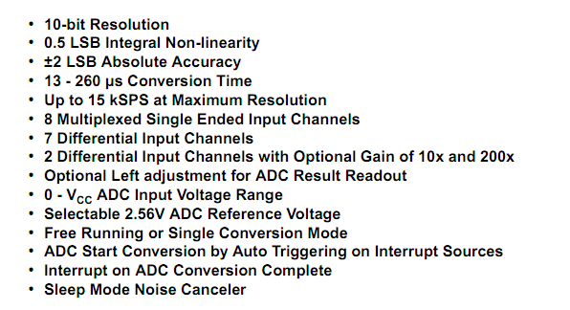](http://maxembedded.files.wordpress.com/2011/06/adc-features-atmega1632.png?resize=596%2C324)

ADC Features – ATMEGA16/32

Right now, we are concerned about the **8 channel 10 bit resolution** feature.

* **8 channel** implies that there are 8 ADC pins are multiplexed together. You can easily see that these pins are located across PORTA (PA0…PA7).
* **10 bit resolution** implies that there are 2^10 = 1024 steps (as described below).

[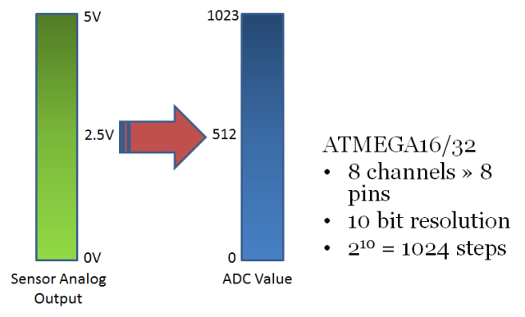](http://maxembedded.files.wordpress.com/2011/06/8-channel-10-bit-adc.png?resize=640%2C387)

8 channel 10 bit ADC

Suppose we use a 5V reference. In this case, any analog value in between 0 and 5V is converted into its equivalent ADC value as shown above. The 0-5V range is divided into 2^10 = 1024 steps. Thus, a 0V input will give an ADC output of 0, 5V input will give an ADC output of 1023, whereas a 2.5V input will give an ADC output of around 512. This is the basic concept of ADC.

To those whom it might concern, the type of ADC implemented inside the AVR MCU is of [Successive Approximation](http://en.wikipedia.org/wiki/Successive_approximation_ADC) type.

Apart from this, the other things that we need to know about the AVR ADC are:

* ADC Prescaler
* ADC Registers – ADMUX, ADCSRA, ADCH, ADCL and SFIOR

**ADC Prescaler**

The ADC of the AVR converts analog signal into digital signal at some regular interval. This interval is determined by the clock frequency. In general, the ADC operates within a frequency range of 50kHz to 200kHz. But the CPU clock frequency is much higher (in the order of MHz). So to achieve it, frequency division must take place. The prescaler acts as this division factor. It produces desired frequency from the external higher frequency. There are some predefined division factors – 2, 4, 8, 16, 32, 64, and 128. For example, a prescaler of 64 implies F_ADC = F_CPU/64. For F_CPU = 16MHz, F_ADC = 16M/64 = 250kHz.

Now, the major question is… which frequency to select? Out of the 50kHz-200kHz range of frequencies, which one do we need? Well, the answer lies in your need. **There is a trade-off between frequency and accuracy**. Greater the frequency, lesser the accuracy and vice-versa. So, if your application is not sophisticated and doesn’t require much accuracy, you could go for higher frequencies.

**ADC Registers**

We will discuss the registers one by one.

**ADMUX – ADC Multiplexer Selection Register**

The ADMUX register is as follows.

[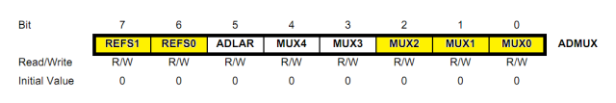](http://maxembedded.files.wordpress.com/2011/06/admux1.png?resize=640%2C107)

ADMUX Register

The bits that are highlighted are of interest to us. In any case, we will discuss all the bits one by one.

* **Bits 7:6 – REFS1:0 – Reference Selection Bits** – These bits are used to choose the reference voltage. The following combinations are used.

[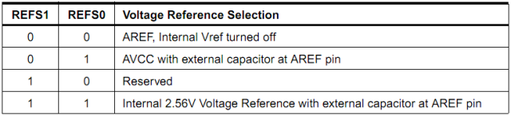](http://maxembedded.files.wordpress.com/2011/06/reference-voltage-selection.png?resize=640%2C145)

Reference Voltage Selection

[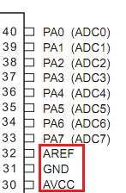](http://maxembedded.files.wordpress.com/2011/06/adc-voltage-reference-pins.png?resize=147%2C224)

ADC Voltage Reference Pins

The ADC needs a reference voltage to work upon. For this we have a three pins AREF, AVCC and GND. We can supply our own reference voltage across AREF and GND. For this, **choose the first option**. Apart from this case, you can either connect a capacitor across AREF pin and ground it to prevent from noise, or you may choose to leave it unconnected. If you want to use the VCC (+5V), **choose the second option**. Or else, **choose the last option** for internal Vref.

Let’s choose the second option for Vcc = 5V.

* **Bit 5 – ADLAR – ADC Left Adjust Result** – Make it ‘1’ to Left Adjust the ADC Result. We will discuss about this a bit later.
* **Bits 4:0 – MUX4:0 – Analog Channel and Gain Selection Bits** – There are 8 ADC channels (PA0…PA7). Which one do we choose? Choose any one! It doesn’t matter. How to choose? You can choose it by setting these bits. Since there are 5 bits, it consists of 2^5 = 32 different conditions as follows. However, we are concerned only with the first 8 conditions. Initially, all the bits are set to zero.

[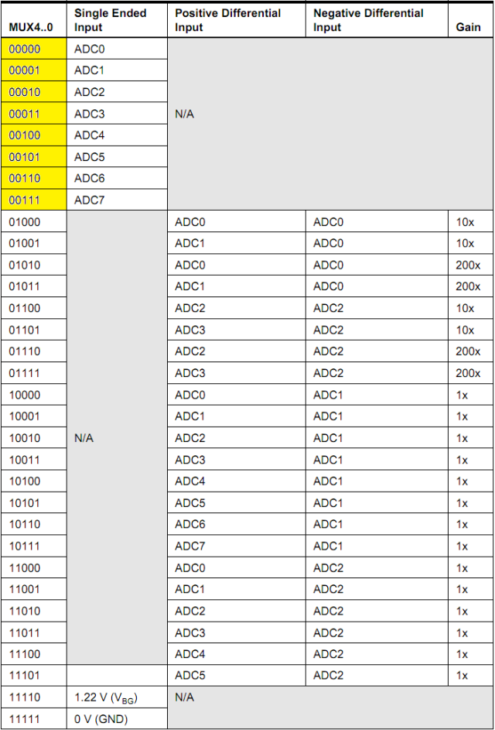](http://maxembedded.files.wordpress.com/2011/06/input-channel-and-gain-selections1.png?resize=640%2C943)

Input Channel and Gain Selections

Thus, to initialize ADMUX, we write

|  |
| --- |
| ADMUX = (1<<REFS0); |

**ADCSRA – ADC Control and Status Register A**

The ADCSRA register is as follows.

[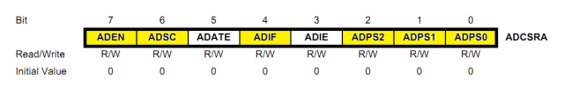](http://maxembedded.files.wordpress.com/2011/06/adcsra.png?resize=640%2C100)

ADCSRA Register

The bits that are highlighted are of interest to us. In any case, we will discuss all the bits one by one.

* **Bit 7 – ADEN – ADC Enable** – As the name says, it enables the ADC feature. Unless this is enabled, ADC operations cannot take place across PORTA i.e. PORTA will behave as GPIO pins.
* **Bit 6 – ADSC – ADC Start Conversion** – Write this to ‘1’ before starting any conversion. This 1 is written as long as the conversion is in progress, after which it returns to zero. Normally it takes 13 ADC clock pulses for this operation. But when you call it for the first time, it takes 25 as it performs the initialization together with it.
* **Bit 5 – ADATE – ADC Auto Trigger Enable** – Setting it to ‘1’ enables auto-triggering of ADC. ADC is triggered automatically at every rising edge of clock pulse. View the SFIOR register for more details.
* **Bit 4 – ADIF – ADC Interrupt Flag** – Whenever a conversion is finished and the registers are updated, this bit is set to ‘1’ automatically. Thus, this is used to check whether the conversion is complete or not.
* **Bit 3 – ADIE – ADC Interrupt Enable** – When this bit is set to ‘1’, the ADC interrupt is enabled. This is used in the case of interrupt-driven ADC.
* **Bits 2:0 – ADPS2:0 – ADC Prescaler Select Bits** – The prescaler (division factor between XTAL frequency and the ADC clock frequency) is determined by selecting the proper combination from the following.

[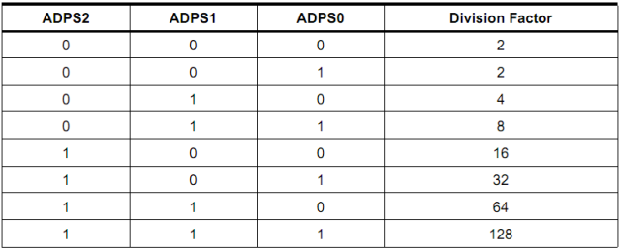](http://maxembedded.files.wordpress.com/2011/06/adc-prescaler-selections.png?resize=640%2C259)

ADC Prescaler Selections

Assuming XTAL frequency of 16MHz and the frequency range of 50kHz-200kHz, we choose a prescaler of 128.

Thus, F_ADC = 16M/128 = 125kHz.

Thus, we initialize ADCSRA as follows.

|  |
| --- |
| ADCSRA = (1<<ADEN)|(1<<ADPS2)|(1<<ADPS1)|(1<<ADPS0);  // prescaler = 128 |

**ADCL and ADCH – ADC Data Registers**

The result of the ADC conversion is stored here. Since the ADC has a resolution of 10 bits, it requires 10 bits to store the result. Hence one single 8 bit register is not sufficient. We need two registers – ADCL and ADCH (ADC Low byte and ADC High byte) as follows. The two can be called together as ADC.

[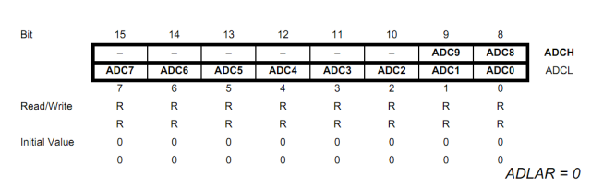](http://maxembedded.files.wordpress.com/2011/06/adc-data-registers-adlar-0.png?resize=640%2C204)

ADC Data Registers (ADLAR = 0)

[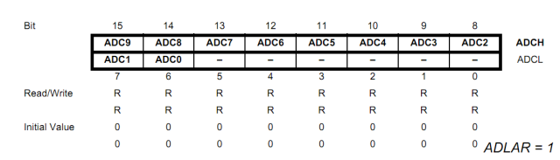](http://maxembedded.files.wordpress.com/2011/06/adc-data-registers-adlar-1.png?resize=640%2C183)

ADC Data Registers (ADLAR = 1)

You can very well see the the effect of ADLAR bit (in ADMUX register). Upon setting ADLAR = 1, the conversion result is left adjusted.

**SFIOR – Special Function I/O Register**

In normal operation, we do not use this register. This register comes into play whenever ADATE (in ADCSRA) is set to ‘1’. The register goes like this.

[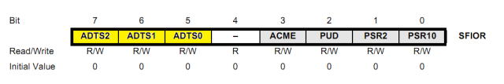](http://maxembedded.files.wordpress.com/2011/06/sfior-register.png?resize=640%2C107)

SFIOR Register

The bits highlighted in yellow will be discussed as they are related to ADATE. Other bits are reserved bits.

* **Bits 7:5 – ADC Auto Trigger Source** – Whenever ADATE is set to ‘1’, these bits determine the trigger source for ADC conversion. There are 8 possible trigger sources.

[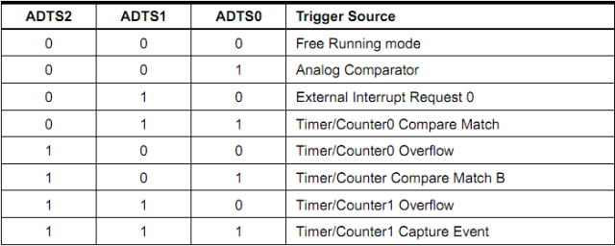](http://maxembedded.files.wordpress.com/2011/06/adc-auto-trigerring-source-selections.png?resize=640%2C256)

ADC Auto Triggering Source Selections

These options are will be discussed in the posts related to timers. Those who have prior knowledge of timers can use it. The rest can leave it for now, we won’t be using this anyway.

**ADC Initialization**

The following code segment initializes the ADC.

|  |  |
| --- | --- |
| 1  2  3  4  5  6  7  8  9 | void adc_init()  {      // AREF = AVcc      ADMUX = (1<<REFS0);        // ADC Enable and prescaler of 128      // 16000000/128 = 125000      ADCSRA = (1<<ADEN)|(1<<ADPS2)|(1<<ADPS1)|(1<<ADPS0);  } |

**Reading ADC Value**

The following code segment reads the value of the ADC. Always refer to the register description above for every line of code.

|  |  |
| --- | --- |
| 1  2  3  4  5  6  7  8  9  10  11  12  13  14  15  16  17  18  19 | uint16_t adc_read(uint8_t ch)  {    // select the corresponding channel 0~7    // ANDing with ’7′ will always keep the value    // of ‘ch’ between 0 and 7    ch &= 0b00000111;  // AND operation with 7    ADMUX = (ADMUX & 0xF8)|ch; // clears the bottom 3 bits before ORing      // start single convertion    // write ’1′ to ADSC    ADCSRA |= (1<<ADSC);      // wait for conversion to complete    // ADSC becomes ’0′ again    // till then, run loop continuously    while(ADCSRA & (1<<ADSC));      return (ADC);  } |

**Physical Connections**

Let’s connect two LDRs (Light Dependent Resistors) to pins PA0 and PA1 respectively. The connection is as follows. The function of potentiometers is explained in a later section, **Sensor Calibration**. You can scroll down to it. ;)

[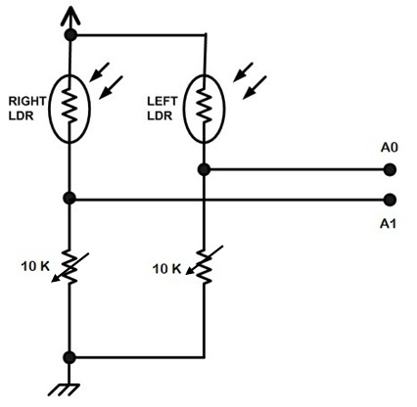](http://maxembedded.files.wordpress.com/2011/06/ldr-connections.jpg?resize=426%2C416)

LDR Connections

Now suppose we want to display the corresponding ADC values in an LCD. So, we also need to connect an LCD to our MCU. Read this post to know about [LCD interfacing](http://maxembedded.wordpress.com/2011/06/16/lcd-interfacing-with-avr/).

Since it is an LDR, it senses the intensity of light and accordingly change its resistance. The resistance decreases exponentially as the light intensity increases. Suppose we also want to light up an LED whenever the light level decreases. So, we can connect the LED to any one of the GPIO pins, say PC0.

Note that since the ADC returns values in between 0 and 1023, for dark conditions, the value should be low (below 100 or 150) whereas for bright conditions, the value should be quite high (above 900).

Now let’s write the complete code.

**Example Code**

To learn about LCD interfacing, view [this](http://maxembedded.wordpress.com/2011/06/16/lcd-interfacing-with-avr/) post. You can type, compile and build it in AVR Studio 5. View [this](http://maxembedded.wordpress.com/2011/06/12/using-avr-studio-5/) page to know how. To know about the I/O port operations in AVR, view [this](http://maxembedded.wordpress.com/2011/06/10/port-operations-in-avr/) page.

[+ expand source](http://maxembedded.com/2011/06/the-adc-of-the-avr/)

**Sensor Calibration**

Calibration means linking your real world data with the virtual data. In the problem statement given earlier, I have mentioned that the LED should glow if the light intensity reduces. But *when* should it start to glow? The MCU/code doesn’t know by itself. You get the readings from the sensor continuously in between 0 and 1023. So, the question is *how do we know that below ‘such and such’ level the LED should glow?*

This is achieved by calibration. You need to physically set this value. What you do is that you run the sensor for all the lighting conditions. You have the ADC values for all these levels. Now, you need to physically see and check the conditions yourself and then apply a threshold. Below this threshold, the light intensity goes sufficiently down enough for the LED to glow.

The potentiometer connected in the circuit is also for the same reason. Now, by the basic knowledge of electronics, you could easily say that upon changing the pot value the ADC value changes. Thus, for various reasons (like poor lighting conditions, you are unable to distinguish between bright and dark conditions, etc), you can vary the pot to get desired results.

This is why I have given the two thresholds (RTHRES anf LTHRES) in the beginning of the code.